Bug reports
- Game does not end when main diagonal is filled:

Description: the game fails to detect a win condition when the main diagonal completely filled with the same symbol ("X" or "O"). This happens regardless of which player completes the diagonal.

Actual Result: the game continues without declaring a winner.
Expected Result: the game should immediately detect the win.

Steps to Reproduce:
- Start a new game
- Fill the main diagonal cells

Environment:
Operating System: Windows 11
Browser: Google Chrome Version 141.0.7390.123 (64-bit)

Attachment:
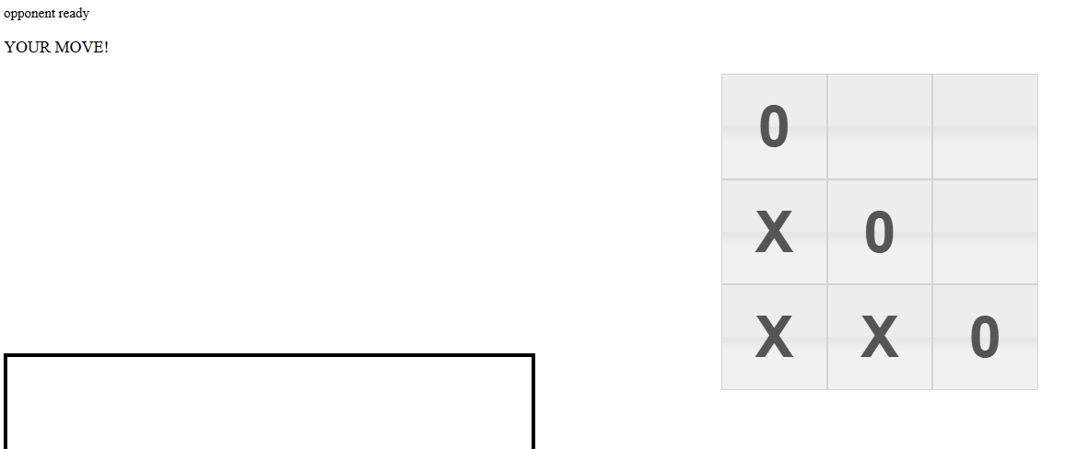
Severity: Major
Priority: High

Improvements: Verify the winner checking logic. Ensure the win-check function explicitly verifies main diagonal.

- Violation of the order of moves:
Description: during the 3rd round, player 2 cannot place an "O" in any cell, and the turn is incorrectly passed to player 1 instead of remaining with player 2.

Actual Result: the turn is not passed to player 1. Player 1 does not place X.
Expected Result: the turn is passed to player 1, and player 1 places X.

Steps to Reproduce:
- Player 1 places an X in any cell.
- Player 2 places an O in any cell.

Environment:
Operating System: Windows 11
Browser: Google Chrome Version 141.0.7390.123 (64-bit)

Attachment:
Player №1 first's turn:
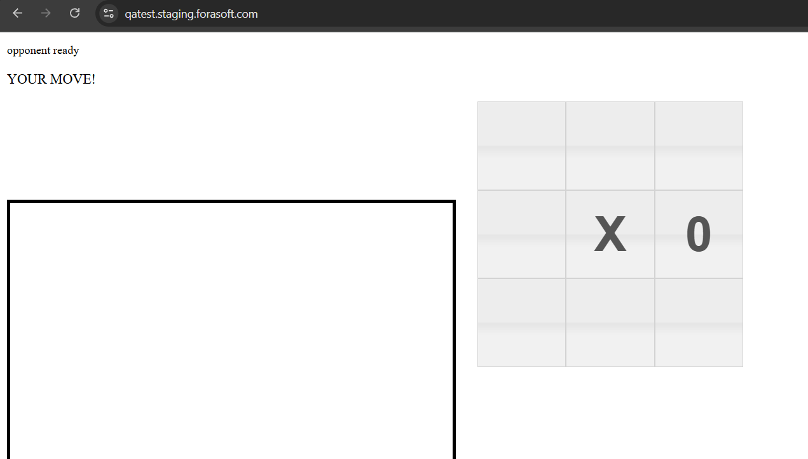

Player №1 second's turn:
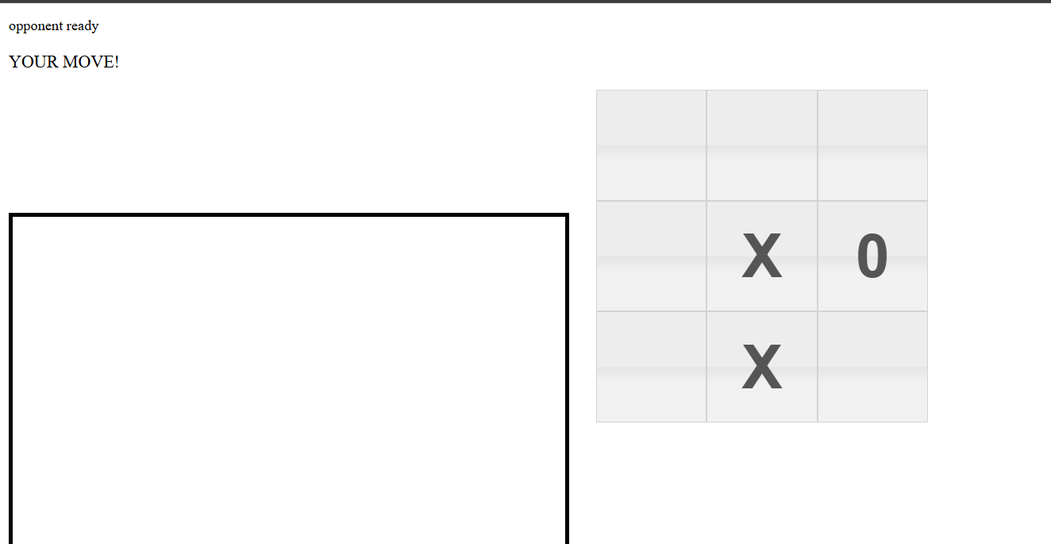
Player №2 is unable to make a move: 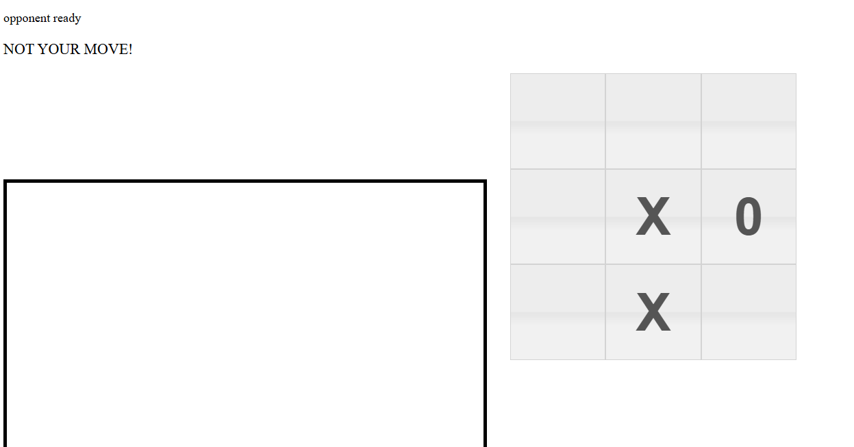

Severity: Major
Priority: High
Improvements: implement a turn validation check to ensure the correct player retains their turn when unable to select a cell.

- Message sending time doesn’t match actual time:

Description: when sending a message in the chat, the displayed time is incorrect, with an additional hour added. For example, the actual sending time is 15:32:35, but the chat displays 15:32:35.

Actual Result: the time displayed in the chat differs from the actual time, with an extra hour added.
Expected Result: the displayed time matches the actual time.

Steps to Reproduce:
- Type letter “f” in the chat.
- Send the message.
- Check the displayed time.

Environment:
Operating System: Windows 11
Browser: Google Chrome Version 141.0.7390.123 (64-bit)

Attachment:
Chat time display:
Actual time:
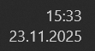

Severity: Minor
Priority: Low

Improvements: adjust the time display logic to correctly reflect the system's actual time zone.

- Ability to send empty messages in the chat:

Description: it is possible to send an empty message by entering a single space (or multiple spaces) in the text field.

Actual Result: An empty message is sent to the chat.
Expected Result: The system should prevent sending messages that contain no text.
Steps to Reproduce:
- Type “ ” in the chat.
- Send the message.

Environment:
Operating System: Windows 11
Browser: Google Chrome Version 141.0.7390.123 (64-bit)

Attachment:
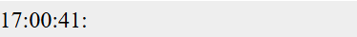

Severity: Minor
Priority: Low
Improvements: disable the send button when input contains only whitespace.

- Chat auto-scroll to bottom does not work:

Description: when new messages arrive (either sent by the user or received from others), the chat window does not automatically scroll to the bottom to show the latest message.

Actual Result: the chat remains in its previous scroll position. The newest message is not visible unless the user manually scrolls down.

Expected Result: the chat should automatically scroll to the bottom every time a new message is added (both when the user sends a message and when a message is received), so the latest message is always immediately visible.
Steps to Reproduce:
- Open the chat
- Send or receive messages until the chat history becomes longer than the visible area and a vertical scrollbar appears.

Environment:
Operating System: Windows 11
Browser: Google Chrome Version 141.0.7390.123 (64-bit)

Attachment:
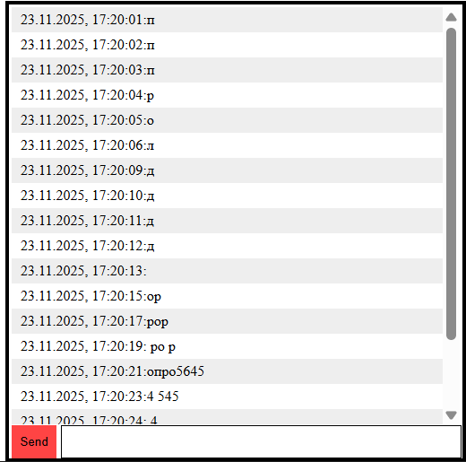

Severity: Minor
Priority: Low

Improvements: trigger auto-scroll after the user sends a message or receiving a new one from the server.

- Long chat messages are not wrapped:

Description: when a user sends a long message, the text doesn’t wrap to the next line. Instead, it forcing a horizontal scrollbar to appear and breaking the overall chat layout.

Actual Result: the message in the chat doesn't wrap and horizontal scrollbar appears.

Expected Result: long text automatically wraps to the next line.
Steps to Reproduce:
- Type a message longer than 80 characters without spaces
- Send a message.

Environment:
Operating System: Windows 11
Browser: Google Chrome Version 141.0.7390.123 (64-bit)

Attachment:
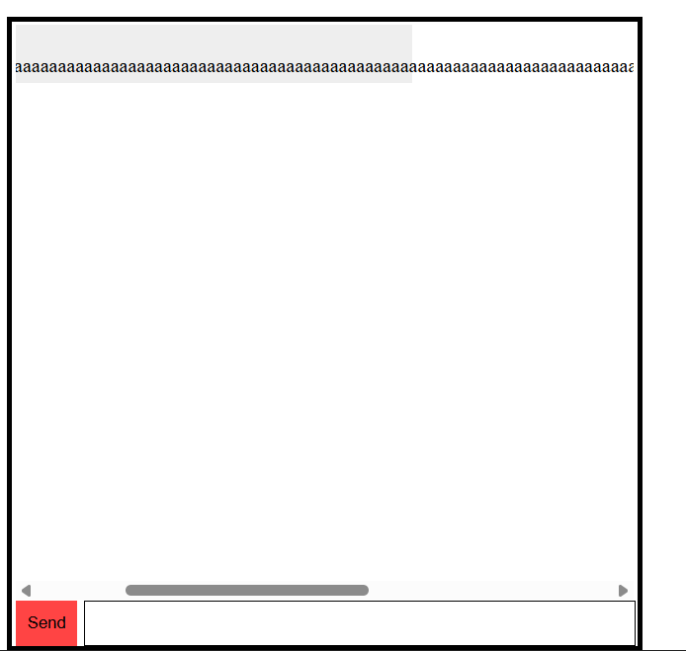

Severity: Minor
Priority: Low

Improvements: fixe CSS wrapping, block horizontal scroll.

- Socket.IO constantly reconnects every ~30 seconds after game start + “send this link to opponent” message is duplicated.
Description: after entering the game and waiting ~30 seconds, the Socket.IO connection reconnects. The process is looped.
Each reconnect triggers the UI to re-display the message “send this link to opponent”, duplicating this message.

Actual Result: every ~30 seconds the socket reconnects, the message “send this link to opponent” is duplicated.
Expected Result: socket connects once and stays connected

Steps to Reproduce:
- Start the game
- Wait ~20 - 40 seconds
- Observe the network page

Environment:
Operating System: Windows 11
Browser: Google Chrome Version 141.0.7390.123 (64-bit)

Attachment:
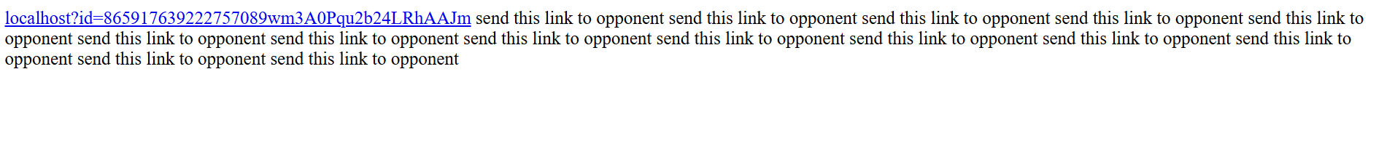
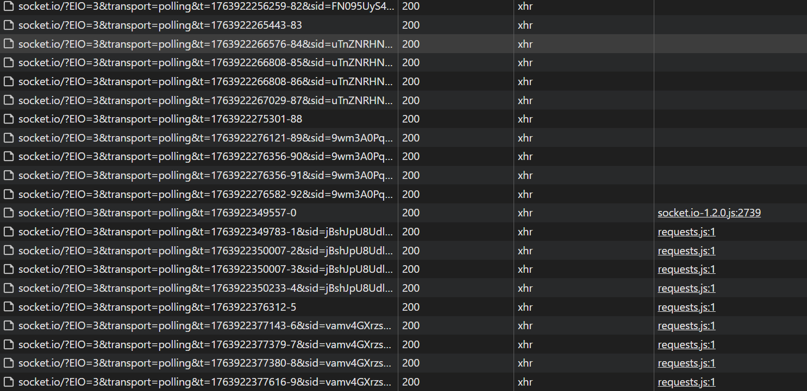
Severity: Major
Priority: High

Improvements: update server configuration
- socket.io response have content-type: text/html instead of application/octet-stream
Description: After launching the game, a post request is sent to socket.io with content-type: application/octet-stream, but the response comes with content-type: text/html

Actual Result: socket.io response have content-type: text/html instead of application/octet-stream
Expected Result: socket.io response have content-type: application/octet-stream

Steps to Reproduce:
- Start the game
- Open the Network page in Devtools
- Reload page
- Click on third polling request

Environment:
Operating System: Windows 11
Browser: Google Chrome Version 141.0.7390.123 (64-bit)

Attachment:
Different content-type
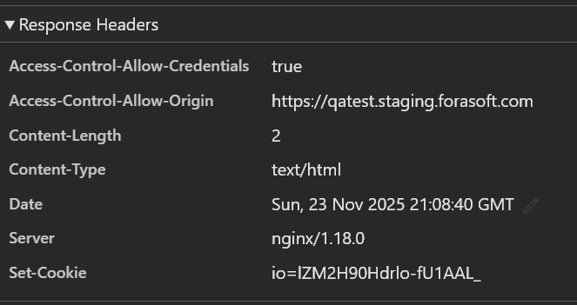 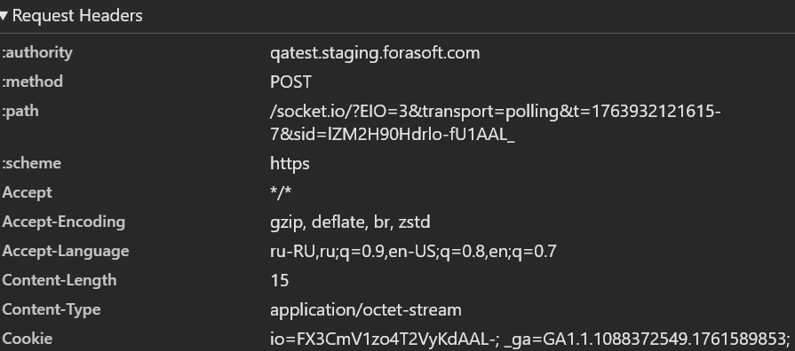
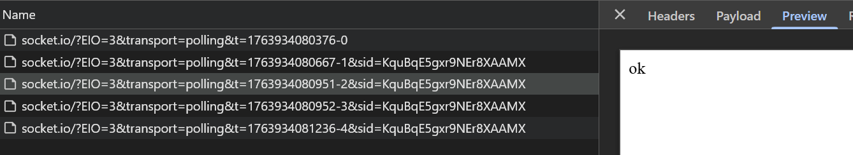
Severity: Major
Priority: Medium

Improvements: set the correct content-type for all socket.io responses

- The losing player cannot send messages in the chat after the end of the game.
Description: After the game has ended, the losing player cannot send messages in the chat, unlike the winning player.

Actual Result: Only winner can send messages in the chat.
Expected Result: Both players can send messages in the chat.

Steps to Reproduce:
- Start the game
- End the game by someone win
- Try to send a message as a loser

Environment:
Operating System: Windows 11
Browser: Google Chrome Version 141.0.7390.123 (64-bit)

Attachment:
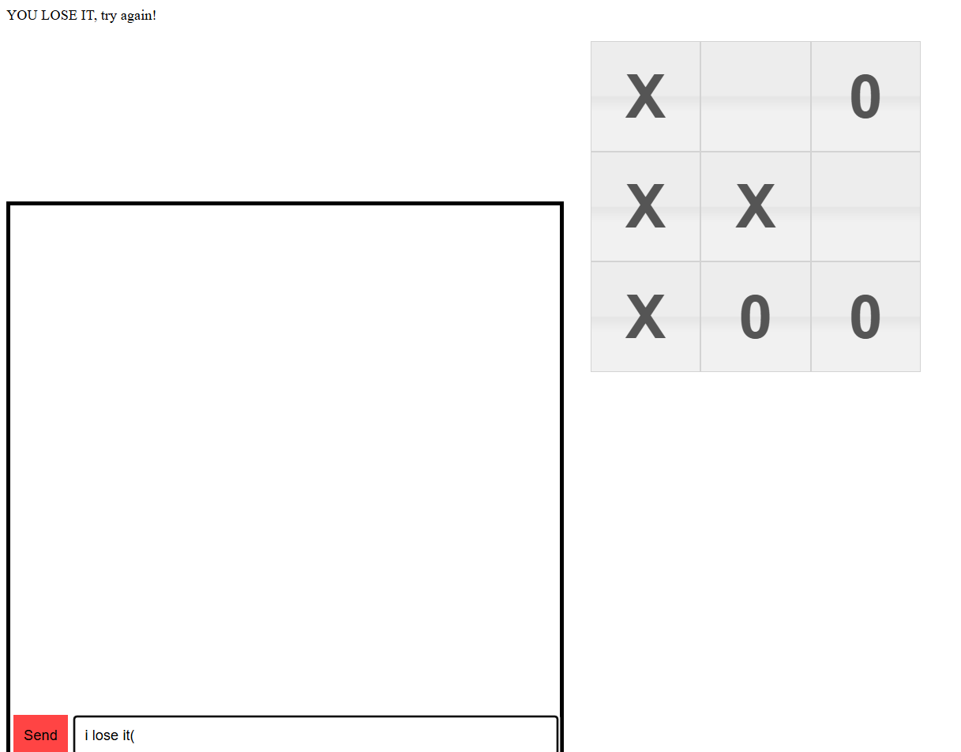

After pressing send button
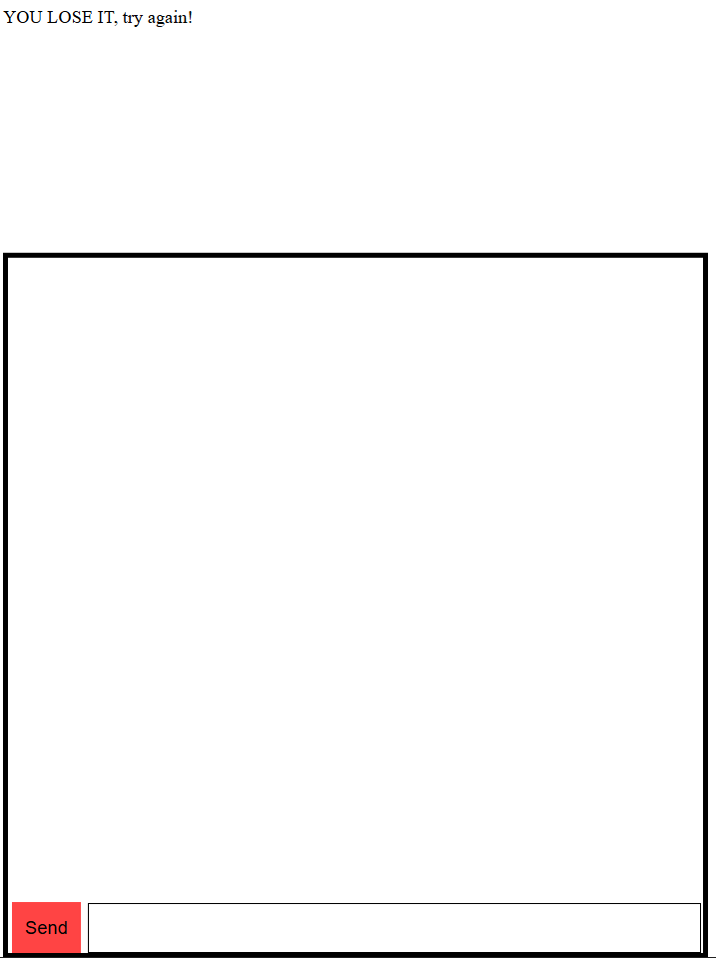
The winner can send a messages:
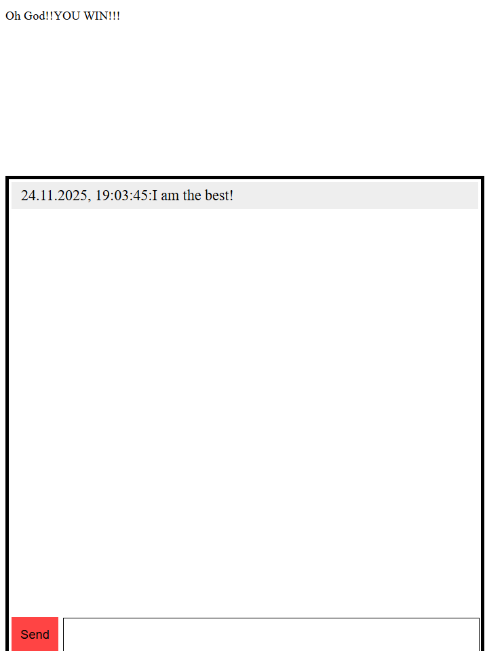
Severity: Major
Priority: Medium

Improvements: unlock the ability to send messages in chat for the losing player.
- XSS in game chat:

Description: In the game chat, you can send HTML/JS code that will be executed for each user.

Actual Result: JavaScript code is executed in the browser.
Expected Result: All HTML/JS code must be escaped.
Steps to Reproduce:
- Type HTML/JS code (for example, <script>alert(“Hi!!!”)</script>) in the chat
- Send a message.

Environment:
Operating System: Windows 11
Browser: Google Chrome Version 141.0.7390.123 (64-bit)

Attachment:
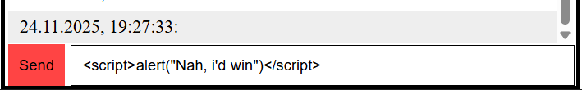\
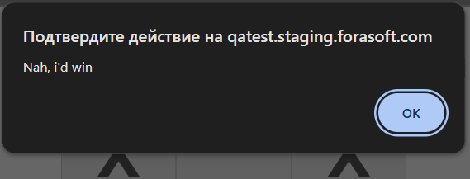
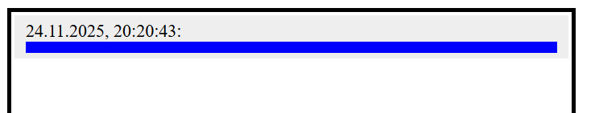

Severity: Critical
Priority: High

Improvements: escape HTML/JS code

- Links in chat messages are unclickable:

Description: When sending a link to a chat, it becomes unclickable.

Actual Result: Links in chat messages are unclickable
Expected Result: Links in chat messages should be clickable ()
Steps to Reproduce:
- Type URL in the chat (for example https://google.com)
- Send a message.

Environment:
Operating System: Windows 11
Browser: Google Chrome Version 141.0.7390.123 (64-bit)

Attachment
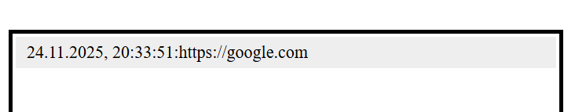

Severity: Minor
Priority: Low

Improvements: implement URL detection and adding links to chat messages.

